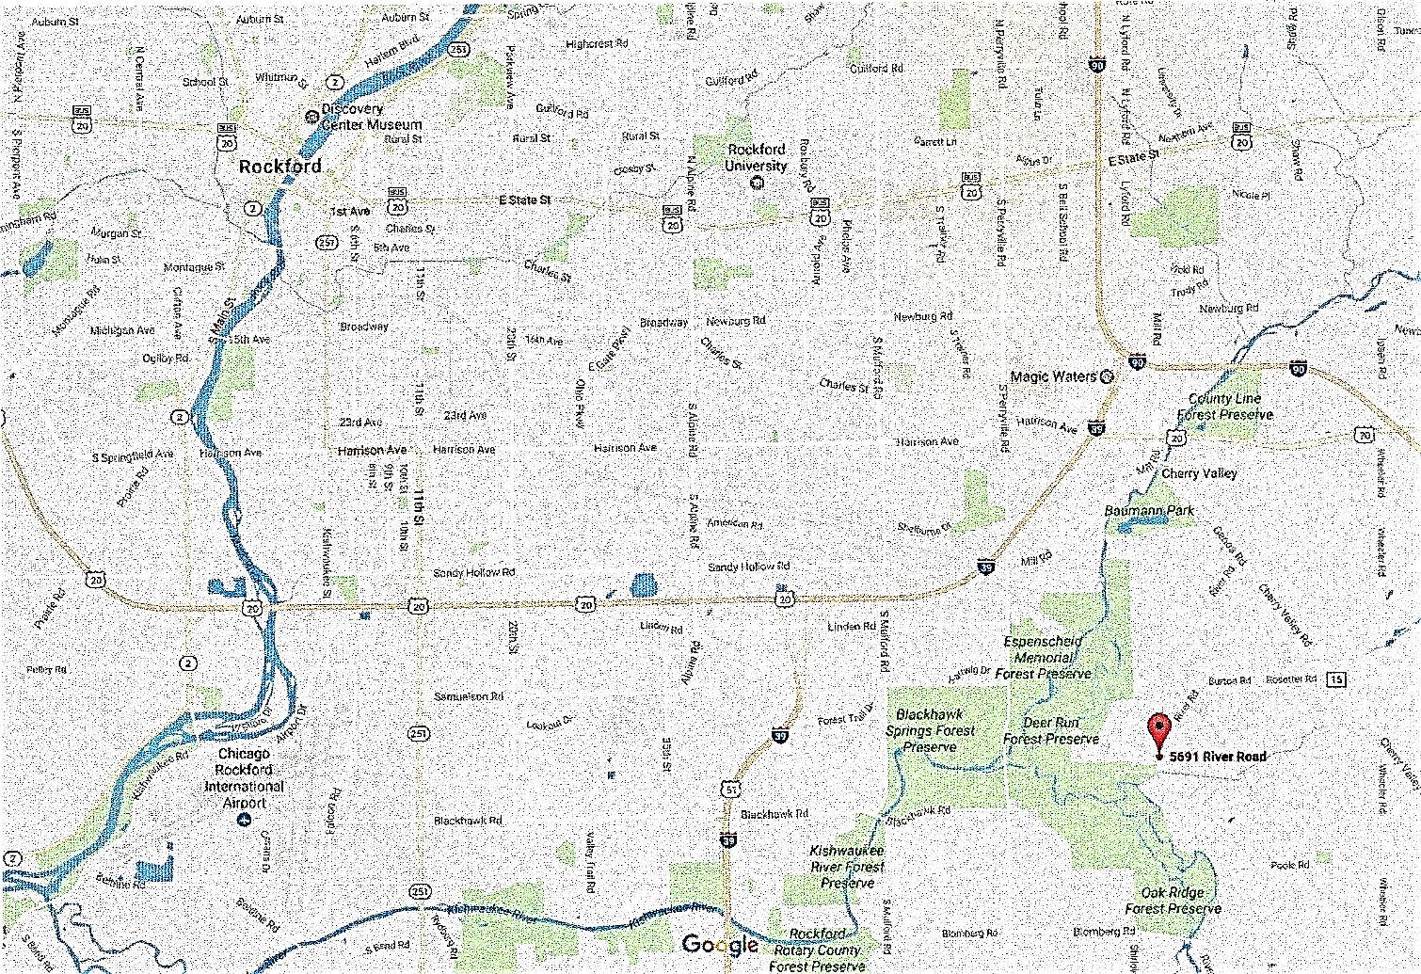Deer Run Forest Preserve, southeast of Rockford, IL at

5691 River Road, Cherry Valley, IL 61016

Premium List event #2020277905

TRACKING DOG EXCELLENT TEST

**PECATONICA TRACKING CLUB, INC.**

Licensed by the American Kennel Club



**Deer Run Forest Preserve**

5691 River Road

Cherry Valley, IL 61016

**Sunday, November 7, 2021**

**7:00am to 5:00pm**

LIMITED to 4 dogs

1 TDX Track will be reserve under the Workers Option Program

Priority will be given to dogs not holding a Tracking Dog Excellent title

**ENTRY FEE is $125.00**

(Includes $0.50 AKC Recording Fee & $3.00 AKC Event Service Fee)

**Entries close Thursday October 20, 2021 at 6pm** at home of test secretary

**Drawing for Entries: Thursday October 20th at 6:30pn**

**at the home of the Test Secretary. The public is invited.**

.

**Draw for tracks:** Sunday November 7, 2021 at: 10:00 am at:

Deer Run Forest Preserve picnic area at end of entrance road.

BITCHES IN SEASON MAY PARTICIPATE in accordance with

*AKC Tracking Regulations*, Chapter 2, Section 8. Please keep bitches in

season in your vehicle and notify the Test Secretary upon arrival.

**JUDGES**

James Ulysses (19384) 4517 Sage Road, Rochester, IL 62563-8350

Connie Austin (19385) 4517 Sage Road, Rochester, IL 62563-8350



**AMERICAN KENNEL CLUB CERTIFICATION**

Permission has been granted by the American Kennel Club for the holding

of this event under AKC Rules and Regulations.

Gina M. DiNardo, Secretary

**PECATONICA TRACKING CLUB, INC. OFFICERS**

President…………………………………Pat Schroder

Vice President............................……………..Penny DuBernat

Treasurer…….……………………………Nancy Einwich

Secretary…………………….………….….. Lisa Warren

3031 Warwickshire Drive, Machesney Park, IL 61115

**BOARD OF DIRECTORS**

Pam German, Jan July, Carla Wolter

**TRACKING TEST COMMITTEE**

Chairperson……………………………………….Nancy Einwich

47W840 Winterset Road, Hampshire, IL 60140

847-340-0983 – nteddy95@aol.com

cell phone day of test only 847-340-0983

Chief Tracklayer……………..……………..………Penny DuBernat

Equipment………………………………………Pam German

all Officers, Board of Directors, & Members

**EMERGENCY INFORMATION**

A first aid kit and cellphones to call 911 will be available at test site.

**Awards**

Each passing dog will receive an enameled club medallion

offered by the Pecatonica Tracking Club, Inc.

**Veterinarian (on call)**  - **Animal Emergency Clinic**

4326 Maray Dr, Rockford (815) 229-7791

**Directions:** to On Call Veterinarian

The veterinary office is located north of the intersection of State St (E-W road) and Alpine Rd (N-S road) on the east side of Rockford, IL, approximately 25 minutes from the test site. Take Blomberg Rd. West to Perryville Rd. Turn right onto Perryville Rd. Travel 4.2 miles to Charles St.., turn left. Take Charles Street 2.7 miles to S. Alpine Rd. turn right. Drive 1.1 miles on Alpine Rd to Morsay Dr., turn left. Drive .2 miles on Morsay Dr. to Maray Dr. and turn right.

“Exhibitors should follow their veterinarians’ recommendation to assure

their dogs are free of internal and external parasites,

any communicable diseases, and have appropriate vaccinations.”

**Please remember to clean up after your dog.**

**ENTRY FEE:** $125.00 (includes $.50 AKC Recording fee and $3.00 AKC

Event Services Fee) Make check or money order payable in US funds to

**PECATONICA TRACKING CLUB, INC.**

Nancy Einwich

47W840 Winterset Road, Hampshire, IL 60140

Returned checks do not constitute a valid entry fee. Test secretary will add a

collection fee to the amount of each returned check.

**Entries must be made on official AKC entry form.**

Do NOT send entries by any method requiring a signature for delivery.

**ALL CANCELLATIONS** of entries must be made in writing to the

Test Secretary & received prior to the stated date and time of closing of entries.

**CLOSING DATE**: **Thursday October 20, 2021 at 6:00pm**

local time at the home of the secretary.

**DRAW for ENTRIES**: held at 6:30 pm local time on Thursday October 20, 2021, at the home of the Test Secretary, 47W840 Winterset Road, Hampshire, IL 61040

The public is invited.

A **worker draw** will be used for this test in accordance with the parameters set forth

in Ch 1, Sec 17c of the Tracking Regulations and as determined by the Board of the

Pecatonica Tracking Club and published in the October 20, 2012, meeting minutes and newsletter. **One track will be set aside for workers at this test**.

Entrants will be NOTIFIED BY PHONE/EMAIL as soon as possible after the draw.. Non-participating alternates’ checks will be shredded within one week after the test, unless return is requested.

**DRAW FOR TRACKS: Draw for tracks:** Sunday November 7, 2021 at: 10:00 am local time at:

Deer Run Forest Preserve picnic area at end of entrance road

First track will run at immediately after, conditions permitting.

**INCLEMENT WEATHER:** In the event of extreme weather conditions the

Club may take such action as necessary to protect the health and safety of the

dogs, handlers and judges, including postponement or cancellation of the test.

LOCATION: Deer Run Forest Preserve is located 3-miles southeast of Rockford, IL at 5691 River Road in Cherry Valley, IL. We will meet at the end of the Deer Run entrance road.

**Dogs shall be on lead at all times.**